WIREFRAMES
These are the wireframes created for the UI of the project. Although most of the parts of the UI are built using these wireframes as a base but some parts may vary due to reasons like, client’s requirements, supervisor or user’s feedback etc. The wireframes are shown below:
This wireframe represents admin login consisting of fields for email and password and a button for sign in.
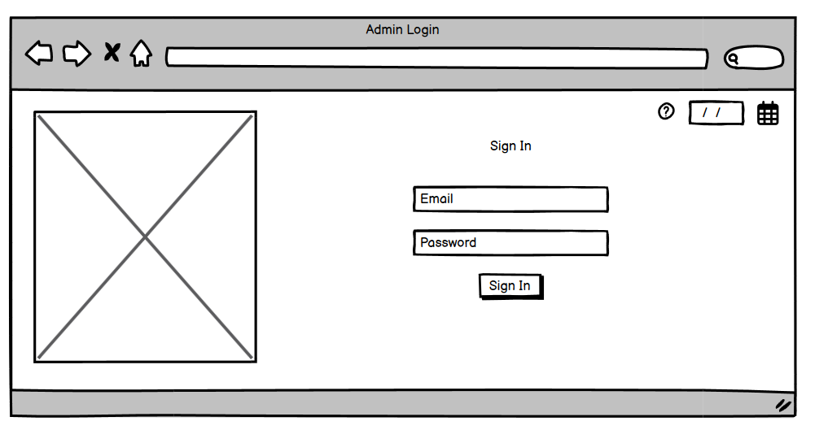
Figure: Wireframe- Admin Login

This wireframe represents Admin Dashboard consisting sidebar with Add candidate, Change phase, voter authentication tabs etc.
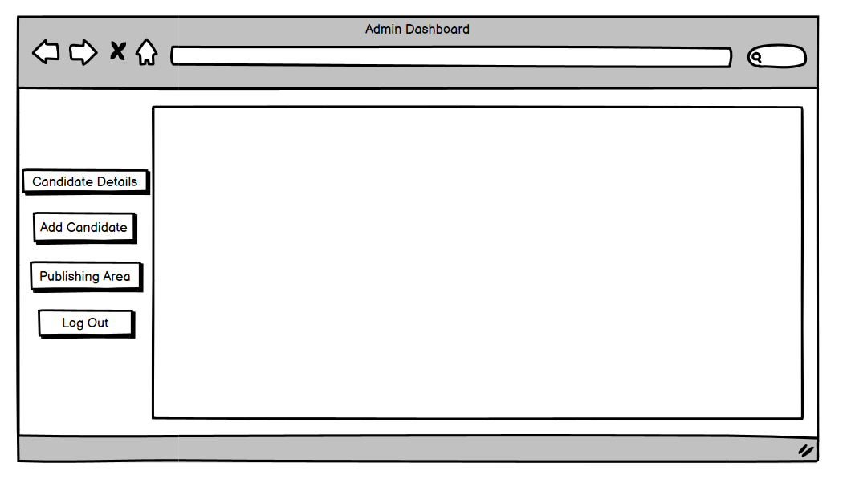
Figure: Wireframe- Admin Dashboard

This wireframe presents voter registration consisting input fields for personal information and a signup button.
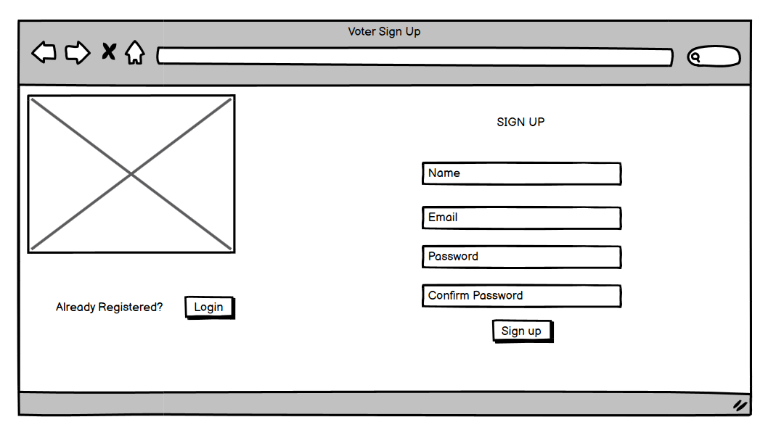
Figure: Wireframe- Voter Registration

This wireframe presents voter login same as admin login it has email and password input field and button for sign in.
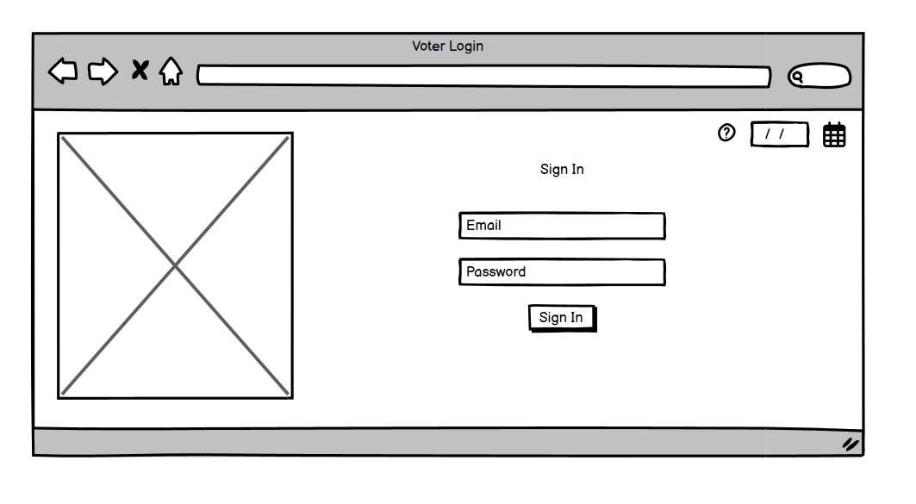
Figure: Wireframe- Voter Login

This wireframe presents voting area/ voter’s dashboard consisting of candidates’ info and a vote button.
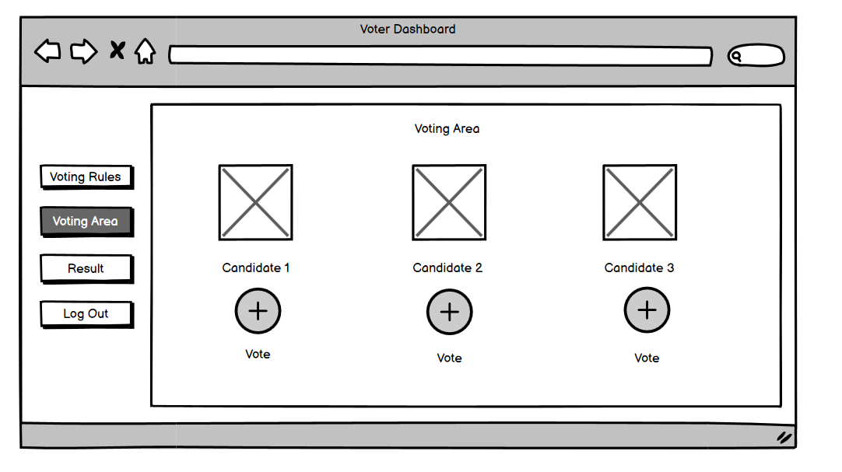
Figure: Wireframe- Voter Dashboard

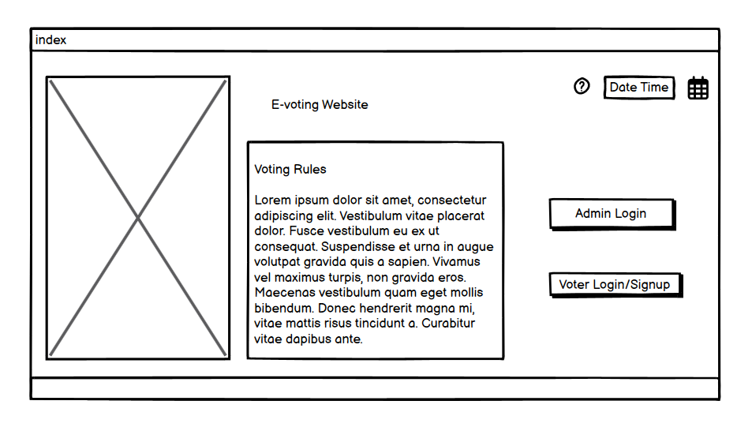
Figure: Wireframe- Landing Page

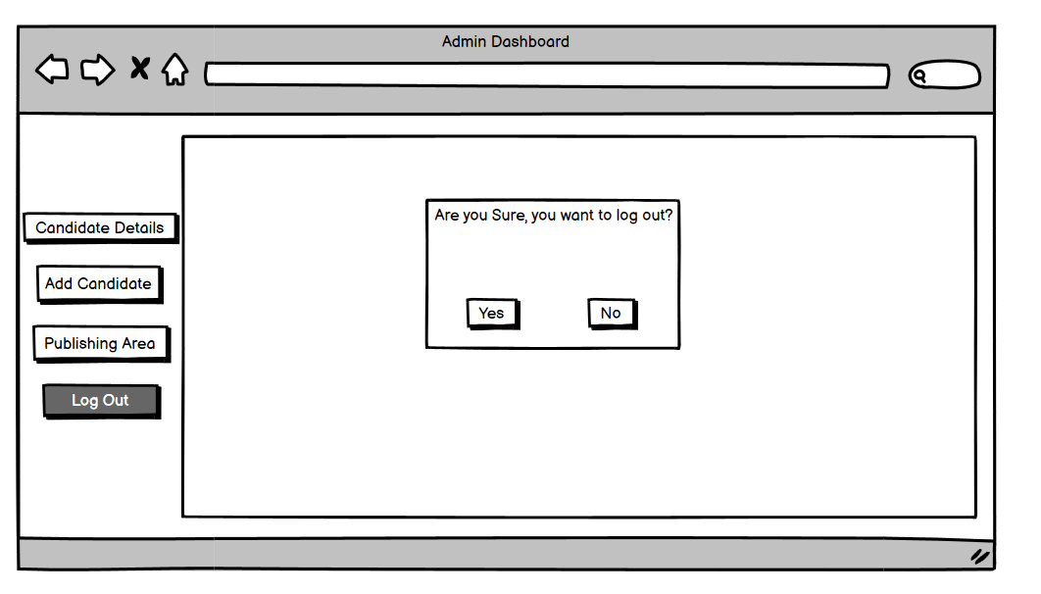
Figure: Wireframe- Logout
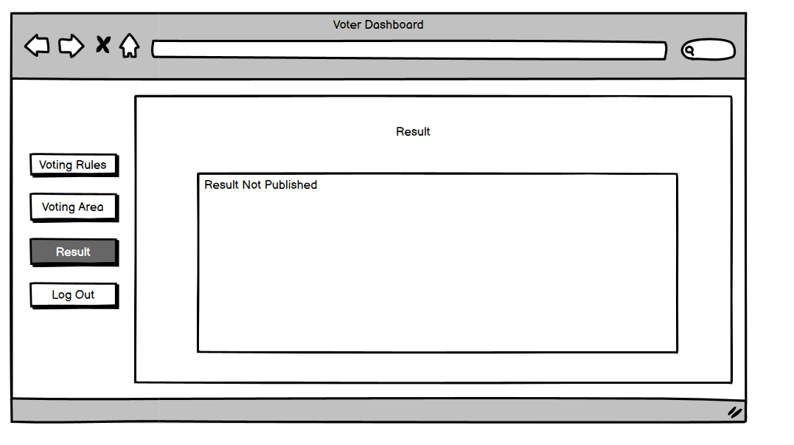
Figure: Wireframe- Result

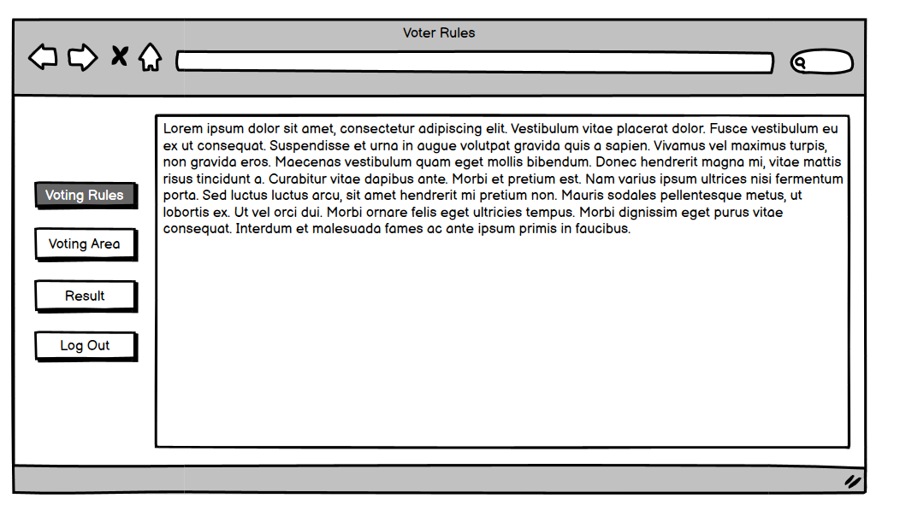
Figure: Voter Rules

